NAME: Surya Krishna Teja Yandra
REG NO:- 192425031

FIGMA EXPERIMENTS

EX 02
AIM:
Sketch a Simple Prototype of a Bus Ticket Booking System using Figma Tool
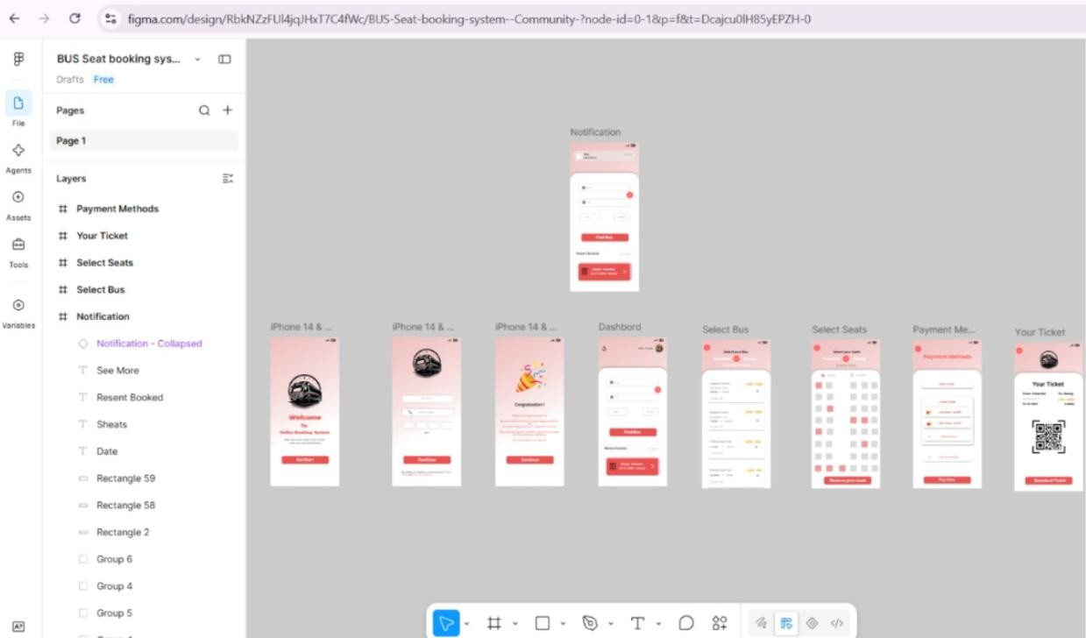

EX03
AIM:-
The stakeholders have conflicting views on the user interface design for an E-Commerce mobile app. Create a prototype using Figma tool to discuss with the stakeholders to get
their feedback and approval.
